USB-Port-GPS Module SKU:EZ-0048
Description:
1.This GPS module supports Raspberry Pi model A,B,A+,B+,Zero,2,3 with its’ L80-39 GPS chip inside.
2.This GPS module can communicates satellite with UART or USB.
3.This GPS module uses CP2102 as USB to UART Bridge chip,it’s stable and faster.
4.The L80-39 with 66 search channels and 22 simultaneous tracking channels,it acquires and tracks satellites in the shortest time even at indoor signal level.

Features:
1.-165 dBm sensitivity,1Hz (default),up to 5Hz,66 channels
2.At least 100mA current draw to start up
3.PPS output can be used to coordinate time with satellite
4.Internal patch antenna which works quite well when used outdoors SMA connector for external active antenna for when used indoors
5.Fix status LED blinks to let you know when the GPS has determined the current coordinates
6.EASY,advanced AGPS technology without external memory
7.Support time service application which can be achieved by PPS sync NMEA feature
8.Built-in LNA for better sensitivity
9.RTC battery-compatible
10.1x8 male headers,USB micro interface
11.Includes CP2102 module serial converter USB 2.0 to TTL UART

Parameters:
1.Satellites:66 acquisition channels,22 tracking channels
2.Work Voltage:4.5-5.5V
3.Maximum Current:100mA （MAX）
4.Scale:16.6*26*18.6mm
5.GPS:L80-M39
6.Patch Antenna Size:15.0*15.0*4.0mm
7.Position Accuracy:<2.5M CEP
8.Velocity Accuracy:<1.0m/s
9.Warm/Cold Start Without ESEY:<35s
10. Warm/Cold Start With ESEY:<15s
11.Acquisition Sensitivity:-148dBm
12.Tracking Sensitivity:-165dBm
13.Update Rate:1Hz (default);up to 5Hz
14.Baud Rate:4800-115200bps;9600bps default
15.Protocols:NEMA 0183
16.Mount Cable:1*8 stacking header;USB micro data cable
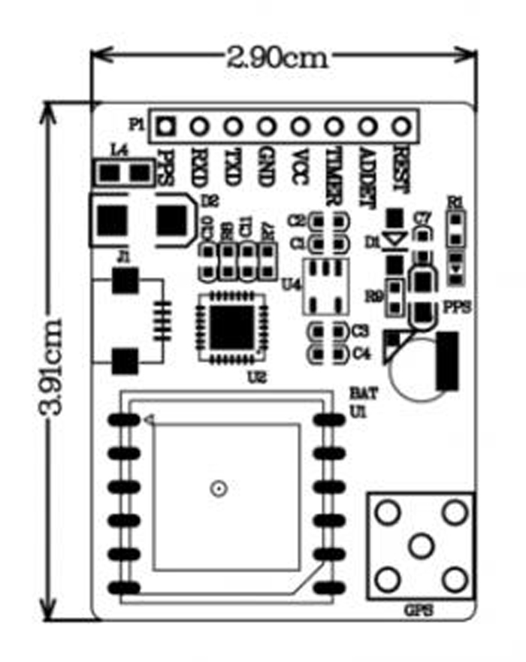
Presentation:
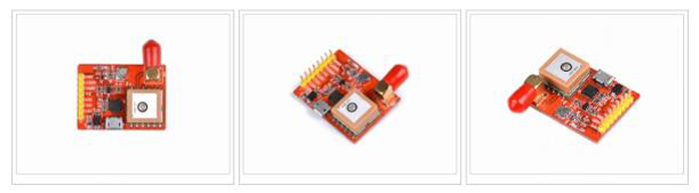

Package Includes:
1.1x USB-Port-GPS (L80-39) module
2.PS:we do not offer micro USB-cable and GPS antenna,you can purchase it if you need

How To Wire It Up:
UART Style:
Because of the serial port issue of Raspberry Pi 3,Module B,it may cause unexpected problem.We suggest that you do not connect GPS module with Raspberry Pi directly with GPIO pins
1.You may need a USB-to-TTL cable to connect GPS module and Raspberry Pi,and you can wire it up like this chart:
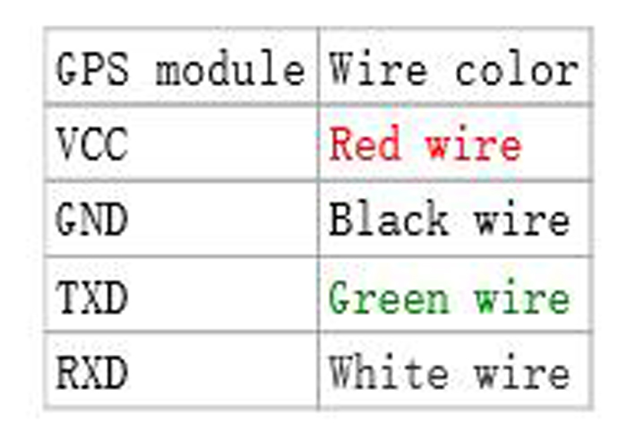
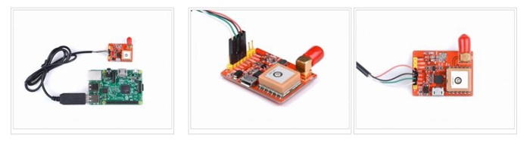
2.Power on Raspberry Pi and login,open a terminal and type following commands if you use Raspberry Pi in desktop environment.

USB Style:
Just use a micro USB cable connect Raspberry Pi USB port with GPS module and power on Raspberry Pi.
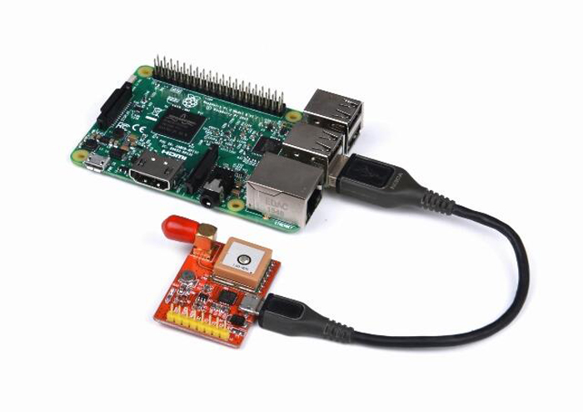
How To Use It:
1.After power on and login to system,you can open a terminal and typing following command to install package for GPS module.
sudo apt-get update && sudo apt-get –y install gpsd-clients python-gps
2.Reboot your Raspberry Pi and login,also typing command in your terminal,it will help you reconfigure your gpsd service:
Sudo dpkg-reconfigure gpsd
3.Start the gpsd service:
sudo gpsd /dev/ttyUSB0- P /var/run/gpsd.sock
4.You can stop the gpsd service:
sudo killall gpsd
5.You can also use systemmctl command to manage this service,but at the first,you should modify the configuration file of gpsd in /etc/default/gpsd,filling the blank with your device name and socket name and path.
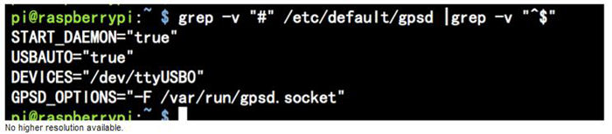
Start Service:
sudo systemctle enable gpsd.sock sudo systemctl start gpsd.sock
Stop Service:
sudo systemctl stop gpsd.sock sudo systemctl disable gpsd.sock
Finally,use this command to get information from GPS module.
sudo cgps –s
You will see this:
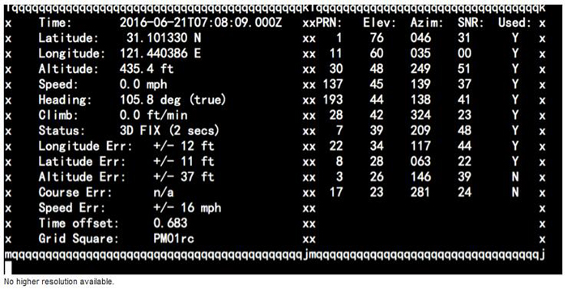Trouble Shooting:
If you can not get the information mentioned before,you can use this command to check if serial is working properly.cat/dev/ttyUSB0 it works fine if you see this picture:
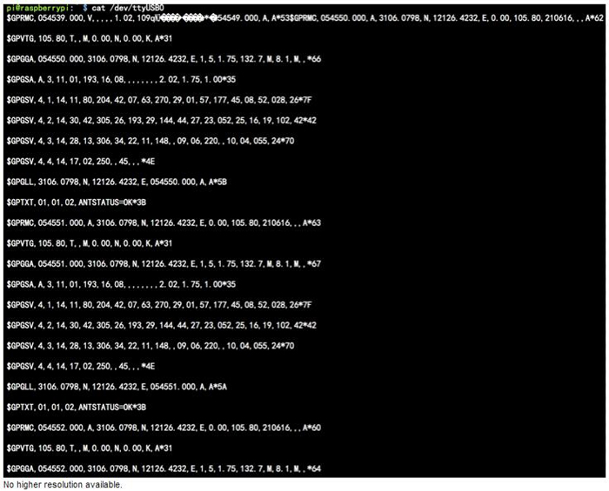
FAQ
Question:I use L80-39 GPS module,I choose to connect the GPS to the Raspberry using a USB port.i followed this steps:
What should I do for NO FIX problem?
Answer:you can modify /etc/default/gpsd file and make sure you input the right arguments as following picture:
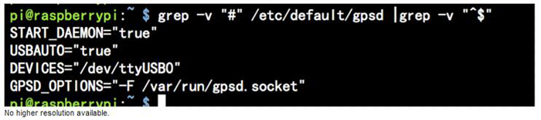
Question:can I use it in my car as a GPS receiver?
Answer:please see this manual and try 1cdgps command.

